WORKSHEET 5
Student Name: Aradhya Sharma UID: 25MCC20042
Branch: MCA (CCD) Section/Group: 25MCC-101A
Semester: 2 Date of Performance: 24 FEB 2026

Subject Name: Technical training Subject Code: 25CAP-652

1. AIM
To gain hands-on experience in creating and using cursors for row-by-row processing in PostgreSQL, enabling sequential access and controlled manipulation of query results for implementing complex business logic.

2. OBJECTIVES
• To understand sequential data access using cursors
• To perform row-level manipulation using procedural logic
• To learn proper cursor lifecycle management
• To handle cursor termination and empty result sets
• To apply cursor-based logic to real-world business scenarios

3. SOFTWARE REQUIREMENTS
Operating System:
• Windows 10 / 11 / Linux / macOS
Database Management System:
• PostgreSQL (version 12 or higher)
SQL Interface:
• pgAdmin 4
OR
• PostgreSQL Command Line (psql)

4. PROCEDURE FOR EXPERIMENT

Step 1: Implementing a Simple Forward-Only Cursor
Objective:
To fetch employee records one by one using a cursor and display them sequentially.
CREATE TABLE employee (
emp_id INT PRIMARY KEY,
emp_name TEXT,
salary NUMERIC,
experience INT,
performance_rating INT
);
INSERT INTO employee VALUES
(101, 'Amit', 42000, 6, 4),
(102, 'Priya', 36000, 3, 3),
(103, 'Rahul', 55000, 8, 5),
(104, 'Neha', 30000, 2, 2),
(105, 'Arjun', 48000, 5, 4),
(106, 'Rohit', 39000, 4, 3),
(107, 'Kiran', 46000, 7, 4),
(108, 'Sneha', 34000, 3, 3),
(109, 'Vikas', 51000, 9, 5),
(110, 'Pooja', 32000, 1, 2);

DO $$
DECLARE
emp_cursor CURSOR FOR
SELECT emp_id, emp_name, salary FROM employee;
v_id INT;
v_name TEXT;
v_salary NUMERIC;
BEGIN
OPEN emp_cursor;
LOOP
FETCH emp_cursor INTO v_id, v_name, v_salary;
EXIT WHEN NOT FOUND;
RAISE NOTICE 'ID: %, Name: %, Salary: %',
v_id, v_name, v_salary;
END LOOP;
CLOSE emp_cursor;
END $$;
Output:
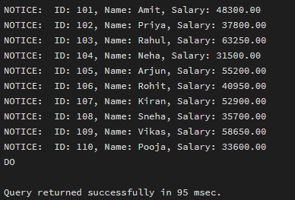

Step 2: Complex Row-by-Row Manipulation
Objective:
To update employee salaries using cursor-based conditional logic based on experience and performance.
Business Logic:
• Experience ≥ 5 and Performance ≥ 4 → 15% increment
• Otherwise → 5% increment
DO $$
DECLARE
emp_cursor CURSOR FOR
SELECT emp_id, salary, experience, performance_rating
FROM employee
FOR UPDATE;
v_id INT;
v_salary NUMERIC;
v_exp INT;
v_perf INT;
BEGIN
OPEN emp_cursor;
LOOP
FETCH emp_cursor INTO v_id, v_salary, v_exp, v_perf;
EXIT WHEN NOT FOUND;
IF v_exp >= 5 AND v_perf >= 4 THEN
UPDATE employee
SET salary = salary * 1.15
WHERE CURRENT OF emp_cursor;
ELSE
UPDATE employee
SET salary = salary * 1.05
WHERE CURRENT OF emp_cursor;
END IF;
END LOOP;
CLOSE emp_cursor;
END $$;
Output:
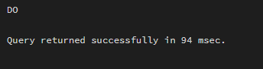

Step 3: Exception and Status Handling
Objective:
To handle empty result sets and ensure safe cursor termination.
DO $$
DECLARE
emp_cursor CURSOR FOR
SELECT emp_id FROM employee;
v_id INT;
row_count INT := 0;
BEGIN
OPEN emp_cursor;
LOOP
FETCH emp_cursor INTO v_id;
EXIT WHEN NOT FOUND;
row_count := row_count + 1;
RAISE NOTICE 'Employee ID: %', v_id;
END LOOP;
IF row_count = 0 THEN
RAISE EXCEPTION 'No employee records found in the table.';
END IF;
CLOSE emp_cursor;
EXCEPTION
WHEN OTHERS THEN
CLOSE emp_cursor;
RAISE NOTICE 'Exception handled safely: %', SQLERRM;
END $$;
Output:
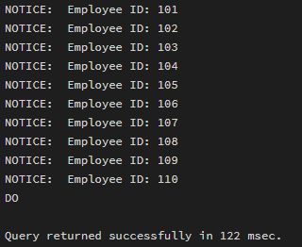

Result Verification

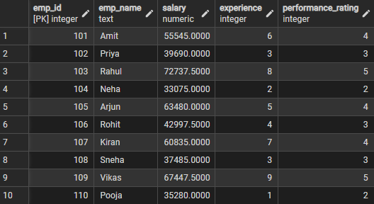

Learning Outcome
This experiment demonstrates effective use of cursors in PostgreSQL for sequential data access and row-by-row processing.
Students gain strong understanding of cursor lifecycle management and exception handling, which is essential for:
• Payroll systems
• Data migration tasks
• Backend application development
• Technical interviews and placements

